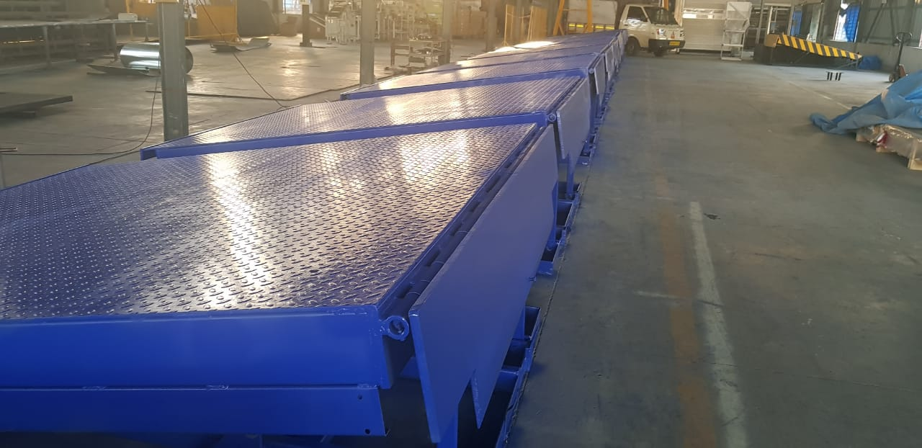

Sr. No | Description | Specifications For 6/10 Ton
1 | Model No | NDL2019_6T/10T
2 | Make | NIHVA
3 | Required Capacity | 6 Ton/10Ton
4 | Hydraulic Power pack | 1 HP, 3PH
5 | Control Panel | 4 Push Button operated
6 | Deck operation | By push button Deck UP & Deck Down
7 | Lip operation | By push button Lip UP & Lip Down
8 | Loading platform height from road Level | 4 feet (1200 mm)
9 | Travel above from Dock level height | 350 mm
10 | Travel below from Dock level height | 200 mm
11 | Deck platform size | (W)2200 x (L)3000 x (H)550 mm
12 | Lip sizes | (W)2200 x (L)400 mm
13 | Clear Pit dimensions | (W)2240 x (L)3000 x (H)550 mm
14 | Power Consumption | 0.75 kw Motor
15 | Degree of protection for motor | IP 55
16 | Motor RPM | 1410 rpm
17 | Pump design flow | 1.8 LPM
18 | Pump pressure | 200 bar
19 | Safety valve set pressure | 120 bar
20 | Pump type | Gear
21 | In built safety valve | Yes
22 | Volume of oil receiver | 8 Ltr
23 | No of Deck Cylinders | 2 Nos
24 | No of Lip Cylinders | 1 No
25 | Dock Plate | 8 mm thick Chequered Plate
26 | Lip Plate | 16 mm thick Plate
27 | Dock Bumpers | 1 Pair included

